Student Transcripts Service
This must be done by all students who think they might want to ever attend a post-secondary institution somewhere in the world…even if they haven’t yet applied. This includes universities, colleges, trade schools, esthetics etc.…
Once completed, this service is completely fluid and flexible and preferences can be added and deleted as plans change (you decide to focus on a different institution, etc.)
- GO TO ORDER TRANSCRIPTS AND CERTIFICATES BC
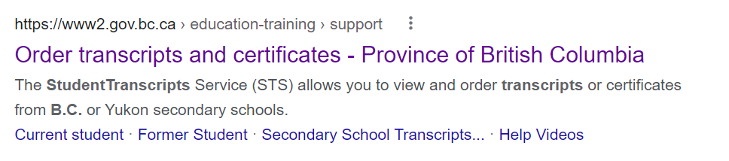

- CLICK ON “CURRENT STUDENT”
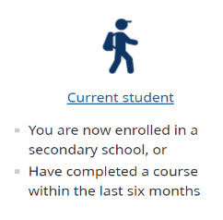

- HAVE THE FOLLOWING INFORMATION READY
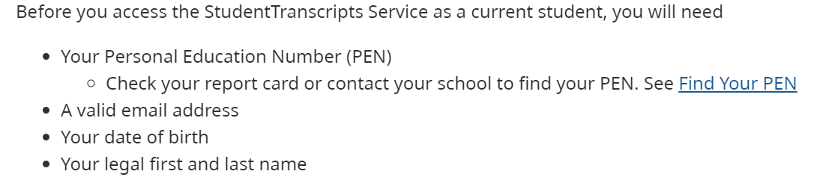

- SCROLL DOWN AND CLICK ON “REGISTER FOR BASIC BCEID”
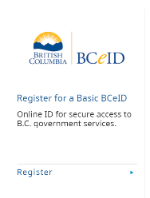

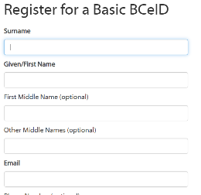

- COMPLETE THE BCEID REGISTRATION
**PICK A USERNAME AND PASSWORD THAT YOU WILL REMEMBER

- GO BACK TO THE ORIGINAL WEBSITE AND CLICK ON RETURNING USER. THERE IS SOMETIMES A LAG AND YOU MAY HAVE TO WAIT A FEW MINUTES OR A FEW HOURS.
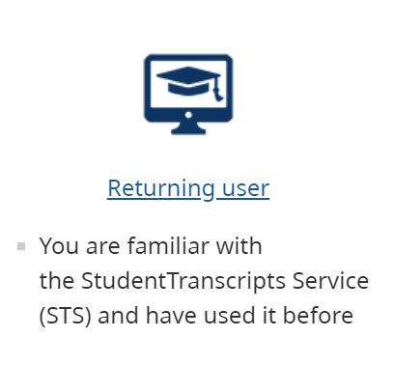

- LOG IN USING YOUR NEWLY CREATED BCEID
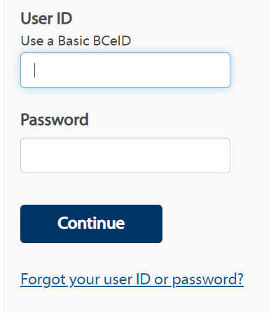

- SELECT “CONTINUE”

- SELECT “SEND/ORDER TRANSCRIPT”
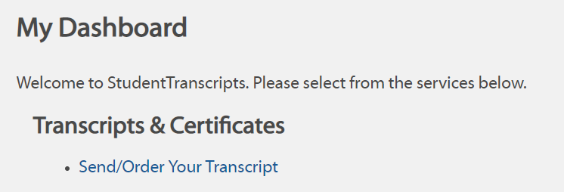

- SELECT “I CONSENT” AND “SEND TRANSCRIPT”
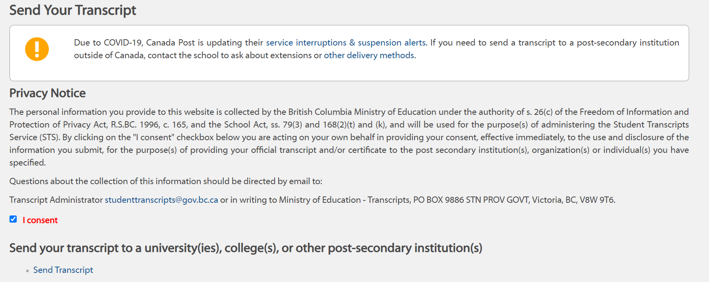

- FIND THE INSTITUTION(S) THAT YOU ARE INTERESTED IN, HIGHLIGHT AND USE THE ARROW TO MOVE OVER TO THE RIGHT SIDE
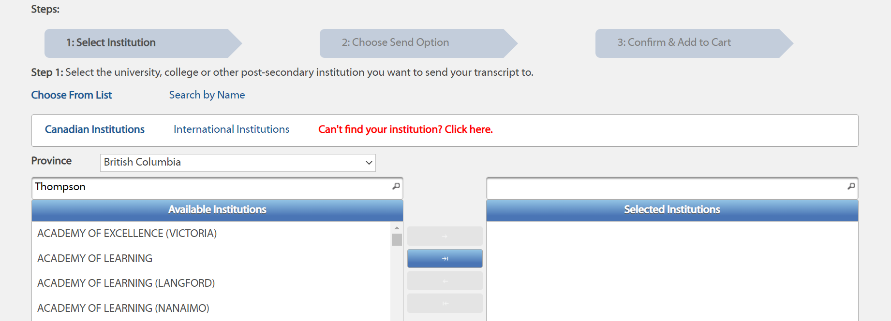

- SELECT “GO TO NEXT STEP”
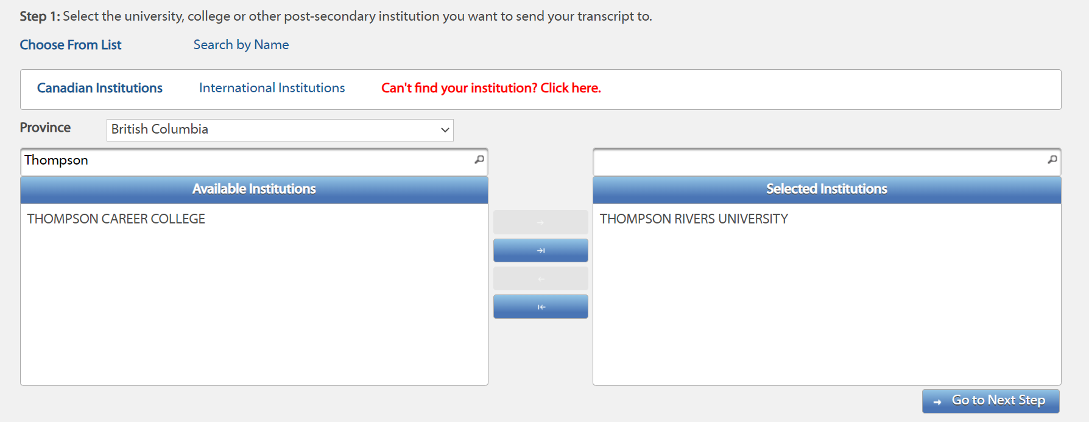

- CONFIRM THAT YOU HAVE YOUR CHOSEN INSTITUTIONS AND CHOOSE “GO TO NEXT STEP”
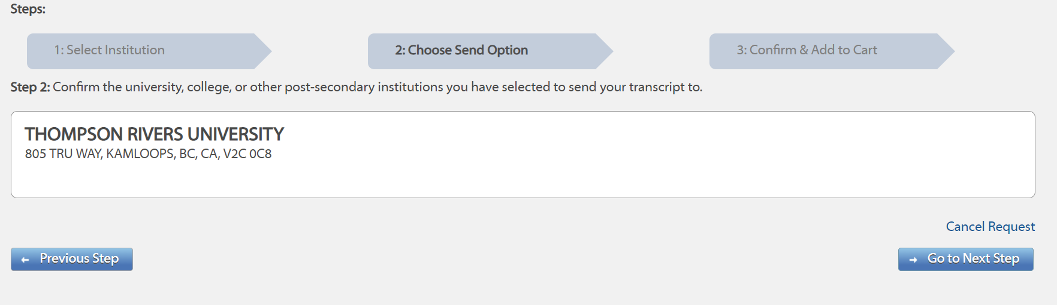

- CONFIRM THAT YOUR TRANSCRIPT LOOKS ACCURATE AND SELECT “I HAVE REVIEWED” AND “ADD ORDER TO CART”
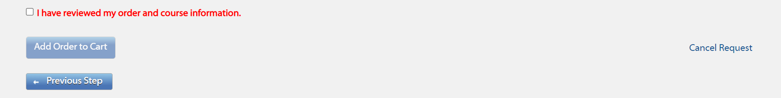

- THERE WILL BE NO COST TO YOU AS YOU ARE A CURRENT STUDENT AND IT WILL SAY SUBMIT ORDER
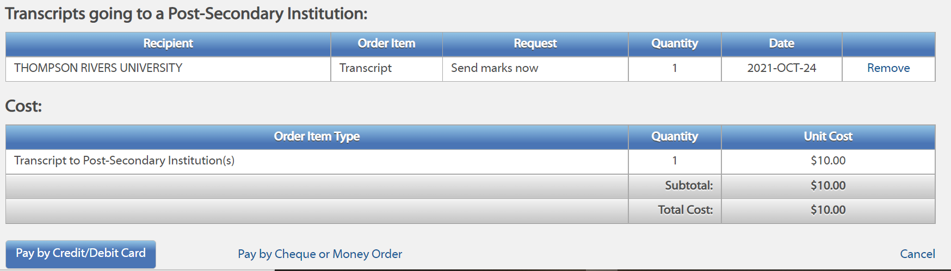

You can add/delete/change these requests at any time. Your transcripts are held in an online database until the institution that you have applied for requests them.
THIS DOES NOT MEAN THAT YOU HAVE APPLIED FOR ANY POST-SECONDARY INSTITUTIONS…that is a separate process. It just means that your transcript is ready for when they ask for it.
You will still access this very same service after you graduate, but you will have to start paying for the transcripts.

