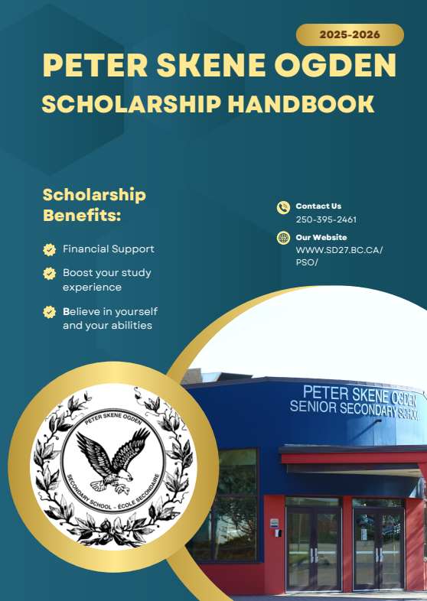
SCHOLARSHIP DEADLINE: March 6th, 2026 at 3:30pm

Table of Contents
Introduction 3
Peter Skene Ogden Local Scholarships/Bursaries Information 4
Outside Agencies Scholarships Information 4
Scholarship Application Documents 6
Sources of Financial Assistance 8
Types of Scholarships 8
Provincial Government Scholarships 8
University/College Entrance Scholarships 10
Outside Agencies Scholarships 11
How Much Will Your Education Cost? 11
General Application 14
Special Application 15
Comprehensive Resume Sample 1 16
Comprehensive Resume Sample 2 17
Letter of Appreciation Sample Guide 18
Cover Letter Example 19

Introduction

Every year in Canada, hundreds of thousands of students—just like you—go to college or university without having the money saved up. They do it because Canada has one of the strongest student support systems in the world.
There are scholarships and bursaries, there are loans, and in some cases, there is loan forgiveness and there are grants, which you never have to pay back. Students use these supports every single year. And you can too!
Here’s the reality:
Minimum-wage jobs in Canada can teach you valuable experience. But long-term? They don’t usually open doors. They always don’t build stability. They don’t tend to grow your income over time.
College and university programs do.
They lead to careers that pay more, that grow more, that offer better benefits, opportunities, and choices. And choice—real choice—is what creates freedom in your life.
Now, here’s the important part:
You don’t need to know exactly what you want to do.
You don’t need straight A’s.
You don’t need a perfect life plan.
You just need to take the next step.
Apply. Explore programs. Ask questions. Take a chance on yourself.
Remember: Post-secondary isn’t the only path, but it’s one of the strongest pathways to long-term financial freedom in Canada.
You don’t need to have it all figured out now. You just need to take the next step—apply, ask questions, explore programs. There are people ready to help you at every point. You are capable. You are worthy. And you’re not doing this alone—there are teachers, counsellors, administration, secretaries and entire support systems here at PSO ready to help you succeed.
We believe in you, and you should believe in your potential and be willing to face new challenges. You can’t discover what’s possible unless you take that first step.

Peter Skene Ogden Local Scholarships/Bursaries Information
Peter Skene Ogden helps to administers funds collected from various individuals, service clubs and other donors.
Awards are available to Grade 12 students proceeding to post-secondary. Students compete with their peers for local scholarship/bursaries.
- Students need to apply for scholarship consideration at the school where they plan to cross the stage for graduation and must be attending the majority of their classes at PSO.
- Grade-Point Average (GPA) must be at least 70% based on grades from Grade 10 through 12.
Please refer to the Peter Skene Ogden Local Scholarships list, provided at the scholarship meeting, also you can get another copy from the office, for a list of the awards available to all PSO graduates. Be aware that this list is subject to change.

Outside Agencies Scholarships Information
There are many scholarships and or bursaries that are offered outside of our school. Please see our school website at www.sd27.bc.ca/pso/ under Students - Graduation – Scholarships – Outside Agency Scholarships

Steps to Completing Scholarship Applications
1. Start Early
- The scholarship process should begin late in Grade 12 year. Your goal is to apply for as many scholarships as possible.
2. Make a spreadsheet of all available scholarships (Optional but helpful)
- Identify the universities you are considering.
- Use scholarship and university websites to make a list of available scholarships.
- Search online databases for scholarship opportunities; see your school counsellor or career advisor for assistance.
- Ask your parents to check at their place of employment.
- Note scholarship deadlines in your spreadsheet.
3. Know What They Want
- Read the criteria carefully and ask yourself ‘What are they looking for?’ Follow the directions given on the application carefully. You will disqualify yourself if you do not!
- Profiles of former recipients are available on some scholarship websites. It can be helpful to review these, so you gain an understanding of the typical candidate who wins the award.
4. Help Your References
- Teachers, coaches, and counsellors are busy! Give referees plenty of time to prepare reference letters or to complete a reference form.
- In your e-mail requesting a reference letter, be sure to include the following information:
◊ Copy of your Comprehensive Resume
*see sample on page 15 & 16
◊ Program you are applying for
◊ Name of scholarship you are applying for
◊ Date of scholarship application deadline.
5. Meet Application Deadline of March 6th, 2026
- Ensure you meet the deadline and be sure to include all supporting documents requested.
6. Neatness Matters
- Your completed application makes a statement about you.
- Presentation is important. Spelling and grammatical errors can disqualify you from consideration.
- Schedule your time to complete the application as though it were a major assignment.
- Ask teachers and parents to proofread your final copy.
7. Do not Email Your Application
- Your application should be dropped off at the office, do not email.
8. Focus on Quality Rather Than Quantity
- Focus on two or three activities and describe your involvement and how you were impacted by the experience.
- Provide specific examples, where possible.
- Ask yourself “What is going to make me stand out over other applicants? What is unique about me?”
9. Keep a Hardcopy
- Keep and electronic and/or photocopy your completed application form.
10. Remember the Basics
- Start early!
- Plan to work on several drafts (photocopy applications and work on the questions until you have decided what to say).
- Fit your answer to the scholarship criteria; use active verbs and provide specific examples.
- Always check your spelling and punctuation (ask an English teacher if they would be willing to edit your application)

Scholarship Application Documents

You will need to submit the following to the office:
  - Scholarship Checklist
    - You are responsible for marking off check list with which scholarships you are applying for, please make this clear as this is what the office works from. This also helps you keep track of which scholarships you apply for.
  - General Application Form
    - If you are applying for ANY general scholarships, you will need to fill out this form just once and have one cover letter.
  - Special Application Form
    - For every special application you are applying for, you will need a form and a cover letter for EACH Special Scholarship. (Special application form, cover letter and any documents requested by the donors. So, for example, if you are applying for 5 special scholarships, you should be handing in 5 forms, with 5 cover letters attached)
Cover Letter
A letter is required with your scholarship application. Write a rough draft and edit your Cover Letter until it is perfect. In many cases the initial screening of candidates will be based on the Cover Letter. Include all relevant information, paying attention to the details specified on the application form. Keep the tone of the letter businesslike. (See example on page 18)
The content of your letter should follow a regular business letter format, and it could possibly contain the following:
- Brief outline about yourself, and what you are planning to do for your future.
- Brief outline of your interests, hobbies, and activities
    - List all school volunteer experience (give some explanation).
    - Include membership in any school-based clubs or committees (e.g. Humanitarian Club, Leadership Club, Environmental Club, Student Council, etc.).
- Summary of positions and offices held by you in school, youth organizations, and the community.
- Short statement of your purposes in seeking to attend college/university (or other post-secondary institution where applicable)
- Information about achievement awards, scholarships and prizes won by you in any field as well as any seminars/conferences attended.
• List work experience, including part-time jobs and summer positions.
- Statement of financial need
Essays
Some donors require you to write an essay. Most of them have a topic they would like you to write about.
If you are looking for more information or help, please speak with Ms. Sviatko or check out this website: https://www.topuniversities.com/blog/how-write-scholarship-application-cover-letter
Letters of Reference
Some scholarship applications require a letter of recommendation or letter of reference. Letters may be written by teachers, members of the community, family friends, or employers. Identify some key people who know you well and ask if they would be willing to write a reference letter for you. Generally, these people can make an honest statement to endorse your application.
Allow plenty of time, two to three weeks on average, for your referee to complete the letter. It is best to have letters from three different people. Read the application carefully as some applications are specific about who provides the letter of reference.
For example: the application may say references from one teacher/counsellor and one community member or one teacher and your school principal. Do not include more reference letters than is required.
Letter of Appreciation
Show your appreciation to the people who have helped you prepare your scholarship/bursary application(s). A short thank you note to the teachers who wrote your reference letters, and to the others who have helped you complete your application package, is appropriate.
If you were fortunate enough to win a scholarship or bursary, it is important to send a thank you note to the donor. Not only is it a common courtesy to thank them for the investment in your future, but it also reminds the organization that supplied the funds that students appreciate the financial assistance they received.
Staying Organized
It is helpful to have all your important documents in one place, such as a 2–3-inch binder. Purchase clear plastic sleeves – use these to keep important documents in one place. For example:
Scholarship Spreadsheet (optional)
It might be a good idea to create an Excel document that has the following fields: Name, Source, Website, Open, Due Date, Amount, Status, Comments. (Please see Mrs. Jackson for a copy of the excel spreadsheet.)
- Use the spreadsheet to track all scholarships that come to your attention.
- Have a system for identifying the scholarships for which you have applied. There is a sample spreadsheet in the “Things to Do” section of the PSO school Scholarship Website
- Using a colour legend will help you track the status of various scholarships.
- Keep all scholarships on your spreadsheet, including those which you are ineligible for; simply strike-through the inapplicable scholarships so you know not to research it later.
- NOTE: When a school nomination is required, it is important to have the ‘due date’ at least a month before the due date
Scholarship To Do List
On page 12 you will find a Scholarship to do list. There is another great tracking tool to see what you must do and keep track of everything you have left to do.

Sources of Financial Assistance
Where is the money going to come from?
The reality of paying for post-secondary education can be challenging for many students and their families. Students need to budget for tuition payments, textbooks, and other educational and living expenses. Many students and their families need to explore additional means to finance the costs of post-secondary education.

Types of Scholarships
There are FOUR basic types of scholarships and bursaries available to high school students:
1. Provincial Government Scholarships. The Provincial Scholarship Program is intended to recognize student achievement and encourage students to pursue post-secondary education. This year there are five scholarships available: the BC Excellence Scholarship, the BC Achievement Scholarship, District / Authority Scholarships and two specific vocational awards for students pursuing either a B.Ed. degree in BC or continuing in the trades training they started in high school.
2. Local Scholarships. Peter Skene Ogden oversees the local scholarships and bursaries which are available to Grade 12 students attending Peter Skene Ogden. We work with private donors, businesses, service clubs, PACs, and other organizations who generously contribute on an annual basis. Donors identify the specific criteria for their award, and it is your job to find out what you need to do to apply.
3. Entrance Awards. Many post-secondary institutions have scholarship, bursary, and award opportunities available to students who apply and are accepted to their institution. Some scholarships are automatically awarded based on academic entrance GPA while others require the completion of a separate application form.
4. Other Scholarship Sources. Students should check to see what scholarships may be available to them; for example: parent’s employer, parent’s affiliations, credit union membership, other affiliations such as clubs (e.g. Girl Guides) or specific criteria (e.g. Indigenous heritage), etc.
NOTE: Our school website contains a database of numerous scholarship opportunities for students to review.
Website: www.sd27.bc.ca/pso/page/791/scholarship-info

Provincial Government Scholarships
To be eligible for the Provincial Scholarships Program, students:
- Must be a Canadian citizen or permanent resident (landed immigrant) the first day of the Grade 12 school year.
- Must be a BC resident.
- Must be or have been enrolled in a BC public school.
A. BC Excellence Scholarship
The BC Excellence Scholarship is a $5,000 award which is awarded to 55 students who were nominated by their school (one nomination per high school). Online application is open in late the Fall and due February 2026. The Ministry of Education looks for demonstrated service and leadership both in school and in the community, and aptitude and commitment to a chosen career path. Additional criteria includes:
- Being able for a Dogwood Diploma
- Minimum “B” average in grades 11 and 12 courses required for graduation
- Minimum "B" (73% or above) in Language Arts 12
- Minimum “B” average, no more than one "C+" (67% or above), and no marks lower than “C+” in courses that fulfill graduation requirements for Science 11 or 12, Math 11, and Social Studies 11 or 12
Students who wish to be considered for nomination must submit the following items to their high school’s scholarship committee by January:
- Resume in the mandatory format.
- 2 Letters of Reference – one from the community and one from your high school
- Essay: written statement prompt invites applicants to reflect deeply on one reason they are pursuing their post-secondary or career pathway.
- https://www2.gov.bc.ca/gov/content/education-training/k-12/support/scholarships/provincial-scholarships
- Voucher must be redeemed within 5 years from September 30th of the student’s graduation year.
Pathways to Teacher Education Scholarship
This BC Ministry of Education scholarship recognizes 20 outstanding Grade 12 students planning to enter the field of teaching with a $5000 tuition voucher to redeem upon entrance to one of BC’s Faculty of Education programs. Online application is open in late Fall 2025.
- Applicants must be BC Residents and Canadian citizens or permanent residents.
- Be eligible for a Dogwood Diploma
- Have the following marks:
  - Minimum “B” average in grades 11 and 12 courses required for graduation.
  - Minimum “B” (73% or above) in Language Arts 12
  - Minimum “B” average, no more that one “C+” (67% or above), and no marks lower than “C+” in courses that fulfill graduation requirements for Science 11 or 12, Math 11 and Social Studies 11 or 12.
Students must submit their application directly to the Ministry of Education by the February 15th, 2026, deadline.
Voucher must be redeemed within 7 years from September 30th of student’s graduation year.
- https://www2.gov.bc.ca/gov/content/education-training/k-12/support/scholarships/provincial-scholarships/pathway-to-teacher-education-scholarship
NOTE: Students MAY apply for both the Pathway to Teacher Education scholarship and the BC excellence scholarship but can be awarded only one.
District / Authority Scholarship Award
The District / Authority Scholarship Award is a $1250 tuition scholarship voucher. Applicants must fulfill the BC Graduation requirements for either the Dogwood Diploma or the Adult Graduation Diploma. Unfortunately, students on School Completion (“Evergreen”) Certificate are not eligible for this award. You can apply for this scholarship through PSO.
Students have the opportunity to apply for the District / Authority Scholarship by demonstrating excellence in one of the following seven categories:
- Indigenous Languages and Culture (leadership at school or in the community with First Nations)
- Fine Arts (Visual Arts, Dance, Drama, Music, Photography, Creative Writing or Film)
- Applied Design, Skills and Technologies (Business Ed, Technology, Media Arts, Home Ec., Tech Ed.)
- Technical and Trades Training (Carpentry, Automotive, Electrical, Hairdressing, Electrical, Culinary Arts – not Work-in-Trades programs)
- Physical Activity (National/ Provincial Athlete, PE 11/12, Dance, Gymnastics)
- International Languages (international languages besides English through course work or external assessments, including AP and IB)
- Community Services (Volunteer Activity – not related to course work, including demonstration of local and global issues and cultural awareness)
Voucher must be redeemed within 5 years from September 30th of student’s graduation year.
For the winning candidates, your District Scholarship award will come directly from the Ministry usually in the late fall (November) of the project exhibition year. Peter Skene Ogden does not issue the scholarship monies.
You will receive a voucher in the mail from the ministry that you will be able to redeem at your chosen post-secondary institute.
Per ministry guidelines the following is provided:
- Winners are not confirmed until the Ministry establishes that eligibility requirements have been met after August 31, 2026
- Winners will be notified, and vouchers will be issued by the Ministry in November 2026
- Winners can also view whether a voucher has been issued by logging into https://www2.gov.bc.ca/gov/content/education-training/k-12/support/transcripts-and-certificates
- Winners will receive their cheques after they have returned their verified voucher or supporting documents to the Ministry for redemption.
If you have any additional questions or concerns regarding how winning scholarships are received, please contact Scholarships@gov.bc.ca
Youth Work in Trades Award
Students who are eligible for the Youth Work in Trades Award will automatically be considered if they are enrolled in the program. There is no need to fill out an application. Please see Heather Wood for more information.
To be eligible, students must:
- Be registered with the Industry Training Authority as a youth apprentice.
- Graduate with a Grade 12 Dogwood Diploma or Adult Dogwood
- Successfully completed WRK 11A, WRK 11B, WRK 12A, and WRK 12B
- Maintain a C+ average or better on Grade 12 numbered courses*
- Must report a total of at least 900 hours to the ITA by Dec. 31 of the school year the student turns 19.
- *Note: A student’s graduation transcript includes the courses the student has passed. The WRK Award uses all courses numbered 12 in the calculation of the grade point average.
- https://youth.itabc.ca/educators/awards/
University/College Entrance Scholarships
All post-secondary institutions administer entrance scholarships for Grade 12 students proceeding directly to studies after high school. Students should check the “Financial Aid” section on each institution’s website for more information.
Eligibility is often based on Grade 11 marks when Grade 12 marks are not available. Many institutions ask Grade 12 students to self-report their first and second term marks. Students must FIRST apply for admissions before they can be considered for any scholarships at an institution.
Many BC post-secondary institutions require applications to be submitted by the beginning of February. (NOTE: UBC requires students to have completed their online application by December 1st.)
Other Scholarship Opportunities
Students are encouraged to check with parent(s), relatives, sports organizations, religious institutions, club sponsors, etc. for scholarship opportunities. Several employers have scholarships available for children or grandchildren of employees.
Scholarships for Youth in Care
Students who have been in care of the Ministry of Children and Families (MCFD) are eligible for many of the above scholarships plus scholarships that are designated for Youth in Care. Some post-secondary institutions waive tuition for students who are in care or have been in care of MCFD.
The following websites will give students more information. Be certain to speak with your school counsellor and/or social worker for more information and assistance.
- Youth Education Assistance Fund (YEAF) https://studentaidbc.ca/explore/grants-scholarships/youth-educational-assistance-fund- former-youth-care
- Federation of BC Youth in Care Networks http://fbcyicn.ca/?scholarships
- Helpful Bursary Resource Guide https://services.viu.ca/sites/default/files/a-guide-to-scholarships- bursaries-tuition-waivers.pdf

Outside Agencies Scholarships
PSO has a list of what we call Outside Agency Scholarships, these are scholarships that are available provincial, country and sometimes out of country. These are updated as we find them or are sent to us. Please check www.sd27.bc.ca/PSO under Students - Graduation – Scholarships – Outside Agency Scholarships

How Much Will Your Education Cost?

College/University websites provide full details about tuition and additional fees. For example, on UBC’s website there is an on-line cost calculator and downloadable budget planning work sheet.
Financing Your Education
Besides scholarships and bursaries, there are several other ways students finance their post-secondary education:
1. Savings
Get in the habit of saving a portion of every pay cheque and keeping it for special purposes. Set yourself a goal of how much you want to have in savings by a particular point in time.
2. Registered Education Savings Plan (RESP)
Many parents have set aside money for their children’s education. It is never too early to discuss with your parents how and if they have planned on assisting you in paying for post-secondary school.
3. Work Part-Time on Campus
Many universities hire their students to work part-time during the school year. Not only does it bring in extra money, but this gives you a chance to get to know the campus and meet people on campus.
4. Apply to do a Co-op Program
Many post-secondary schools have co-op programs. If accepted into a co-op program, you will be able to work in different types of work environments and get paid. This can help you get work experience and fund your education. It may take you one or two more terms to graduate but you will graduate with a more well-rounded education and experience to add to your resume. In your first year of post-secondary studies, find out about the opportunities available to you to do co-op or study and travel.
5. Student Loans
Student Aid BC helps eligible students with the cost of their post-secondary education through loans, grants, and other programs. If you are a B.C. resident planning to attend a college, university, public institute or private training school, you have the primary responsibility of paying for your education; however, if you are not able to afford your studies, StudentAid BC may be able to supplement (not replace) your own financial resources. B.C. student loans are provided by the provincial government and Canada student loans are provided by the federal government. These loans are managed as a single Canada-B.C. integrated loan at the National Student Loans Service Centre (NSLSC).
There is a single application for loans and grants. https://studentaidbc.ca/

Scholarship To Do List

Read the Scholarship Handbook
Highlight sections for future reference.
Prepare your Resume (optional but a donor may request this)
Prepare draft of Cover Letter
Prepare draft Scholarship Essay
Request Letters of Reference
One or two from school personnel
One or two from community members
Write notes of appreciation to those who provided you with a Letter of Reference
Prepare a Scholarship Binder (optional)
Plastic folders with copies of: Transcript, Letters of Reference, draft Scholarship Essay, draft Cover Letter
Prepare a Scholarship Spreadsheet (optional)
Fields may include: Deadline, Scholarship, Website, Criteria, Required Document, Status
Survey all available Scholarship Opportunities
Review the Financial Aid section of university websites.
Note application deadlines in your Scholarship Spreadsheet
Check parental affiliations with unions, through employment and other sources.
Join scholarship search databases which provide you with scholarships specific to your future plans.
Submit scholarship applications by the deadline! March 6th, 2026 at 3:30
Write a thank you letter or note when you are awarded a scholarship.

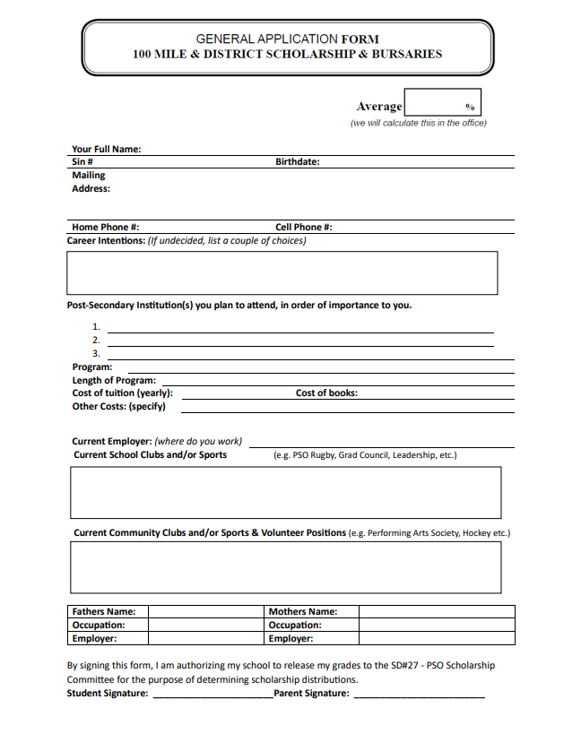
General Application

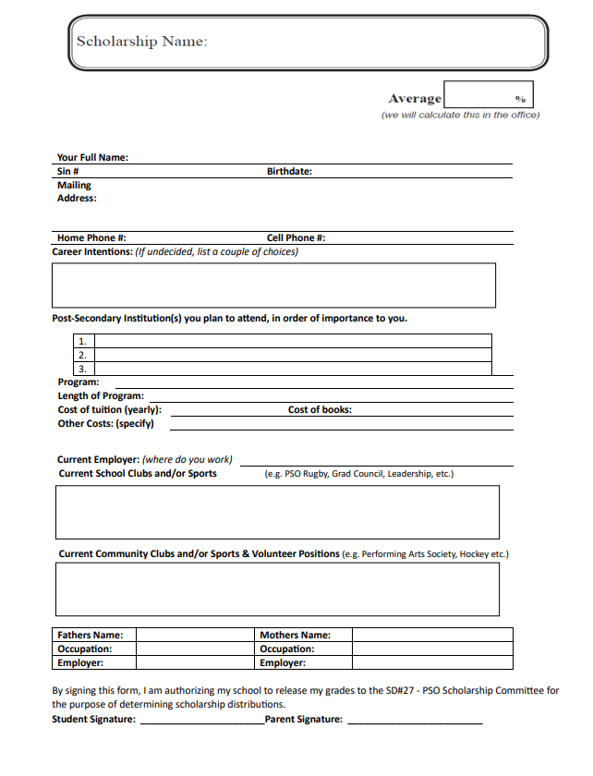
Special Application

Comprehensive Resume Sample 1
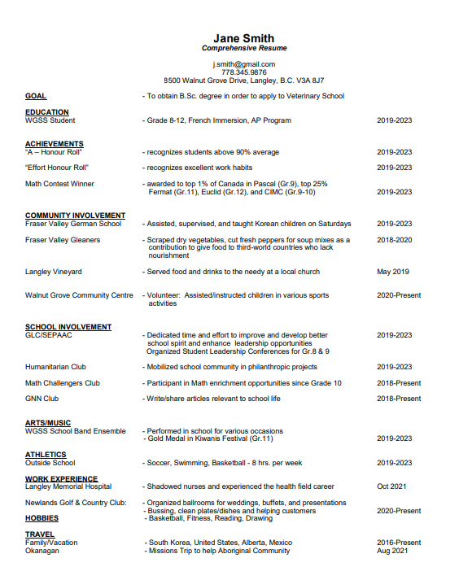

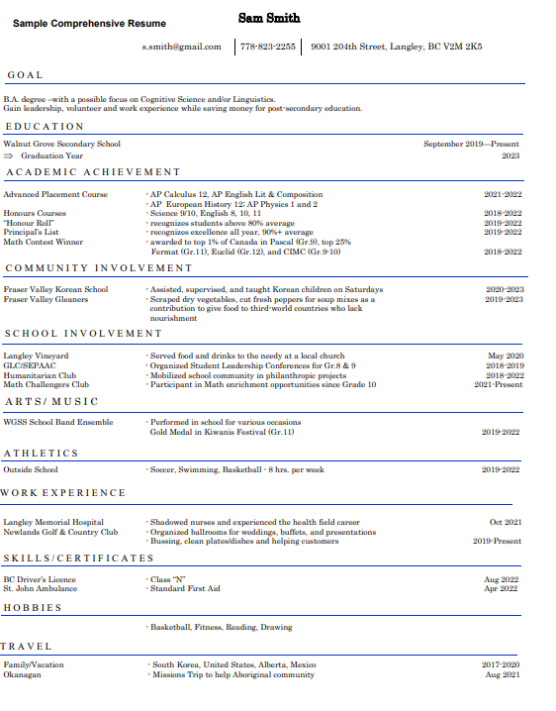
Comprehensive Resume Sample 2

Letter of Appreciation Sample Guide
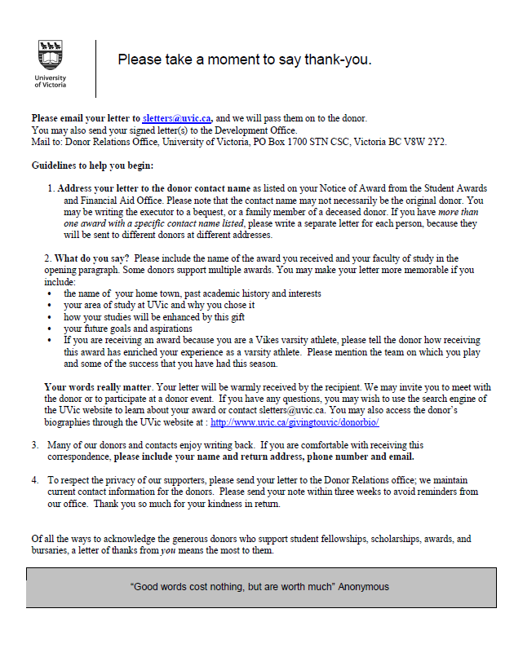

Cover Letter Example

SAMPLE COVER LETTER FOR SCHOLARSHIPS
Nicki Jackson
555 Anywhere Street
100 Mile House, BC V0K 2E1
250-555-5555
January 18, 2024
Dear Scholarship Selection Committee:
My name is Nicki Jackson and I am applying for the 100 Mile Performing Arts Society Bursary.
(Use this paragraph to tell your reader basic information about yourself and why you are applying for this particular scholarship. Use simple, direct statements. Tell them about you, your family, your background and anything else that may be of interest to your recipient.)
During my high school years I . . .
(Use this paragraph to tell the reader about some of the classes you have taken and your extra-curricular clubs, sports, and activities. Mention your hobbies, outside interests and any job or volunteer experience that you may have. You may want to mention any valuable experience you have gained from a particular volunteer effort. )
After I graduate from high school I plan to . . .
(Use this paragraph to tell your reader about your plans for the future, as they apply to the scholarship. Mention the school that you have your eyes on and what you intend to study. Are you going to go to seek a job and go to school at the same time? What are your plans for after college? Most importantly, describe why you need the scholarship money. How will this scholarship help you? Have you received other scholarship funds already?)
Thank you for considering my application...
(Be sure to thank the scholarship sponsor for considering your application letter.)
(Attach your required documents, like letters of recommendation, transcripts, and any other required information to this letter or your completed application.)
Sincerely,
(Sign your name)
Nicki Jackson

